The Honourable Brenda Bailey, M.L.A.
Minister of Finance
Government of British Columbia
PO Box 9048 Stn Prov Govt
Victoria, BC V8W 9E2
Canada

Dear Minister Bailey:

As an owner of a locally owned textile business successfully operating in the province of British Columbia for over 17 years to date I would like to voice my dissent to the removal of slow fashion and mending materials/services as essential needs that warrant PST-exemption status in this province. Specifically, I ask your support in retaining the PST exception on fabric, yarn, natural fibres, and synthetic thread that are commonly used in making or repairing clothing.
The collection of PST from garment mending, yarn, fibre and other fibre arts materials used to create long-lasting ethically-created clothing that evades the landfill will NOT outweigh the inevitable cost of its economic impact. Not only will the addition of the proposed 7% PST burden the economy and small businesses such as ours by decreasing immediate sales, we will also be hit with increased cost of business in administrative costs of other services included in this change. Together this will result in the end of many small businesses already struggling in today’s unstable economy.
We question the choice of putting the burden of this budget on the backs for small business owners that build the community in many ways: providing alternatives to overseas production; serving under-resourced groups and communities; creating third-space community growth opportunities; and actively promoting environment impact alternatives. We provide therapeutic recreation through fibre arts, open discussions with your constituents on the impacts of fast fashion, and create and sell quality products that are intended to be used, reused, and mended. While the money the province sets to collect from this group would be arguably inconsequential in BC’s overall budget, this increase is significant to our customers and could have an extremely detrimental impact on their spending habits and in turn our economy.
Our reach is vast; customers of businesses such as ours are your constituents and will notice that their local community businesses cease to exist, or that their options to slow fashion and mending disappear. We represent a number of tiny industries that generate huge economic value in our social fabric, including the creation of living wage jobs and the well-being of our communities, that are not being accounted for in this proposal. Please consider our local businesses as the stewards of our community and celebrate the essential services they provide.
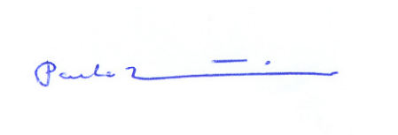
Respectfully,

Paula Lindner,
Owner, Baaad Anna’s Yarn Store

